3 Defining JSF Managed Beans

Overview
In this lab you will extend the functionality of the "Shopping" Web application you created in the previous lab. Here's a quick reminder of how the shop.xhtml page appears at the moment:
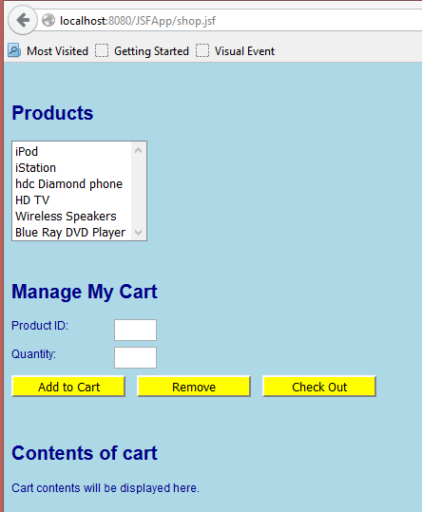

You will define two managed beans for the Web application:
- CartBean – A session-scope bean that holds the customer's shopping cart.
- ShopBean – A request-scope backing bean for the shop.xhtml page.
You will also modify the shop.xhtml page to bind various controls and events to these beans.

Roadmap
There are four exercises in this lab:
- Define the CartBean session-scope bean.
- Define the ShopBean request-scope bean.
- Bind UI controls and events to the managed beans.
- Display the contents of the shopping cart.

Step 1: Define the CartBean session-scope bean
In this exercise you will define a session-scope managed bean named CartBean. This bean will have an ArrayList of all the items in the customer's shopping cart.
The first step is to define an Item class, to represent one item in the shopping cart:
- In the package com.ait.jsf, create a new Java class named Item.
- Paste-in the contents of the prewritten Item class.
- Review the source code in the Item class. The class contains the product ID and quantity for an item in the shopping cart. There are getters and setters for these fields, plus a couple of constructors. There is also an equals() method that deems two Item objects to be "equal" if they have the same product ID.

Create a new Java class named CartBean and annotate it with @ManagedBean and @SessionScoped. The default bean name will be cartBean (note the lower-case c).
Implement the CartBean class as follows:
- Define and instantiate an ArrayList<Item> instance variable named items, and define a getter/setter.
- Define a public method named addItemToCart(). The method should take two int parameters – product ID and quantity. The method should create a new Item from these values, and call items.add() to add it to the list.
- Define a public method named removeItemFromCart(). The method should take a single int parameter – product ID. The method should create a new Item from this value, and call items.remove() to remove it from the list. (The ArrayList will remove the first Item that it finds with the same product ID, based on the implementation of the equals() method in the Item class).
- Define a public method named getItemCount(). The method should return an int, indicating the number of items in the ArrayList (use items.size() to get this info).

Step 2: Define the ShopBean request-scope bean
Define a request-scope managed bean named ShopBean, to act as the backing bean for the Shop.xhtml page.
Add the following members to the bean, to hold data for the page and to handle its events:
- productID and quantity instance variables ( both ints) – Hold the product ID and quantity values entered by the user on the page.
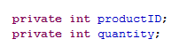
- Getters and setters for productID and quantity.
- addHandler() method – Handles the "Add to Cart" button click event, to add an item to the user's shopping cart. To do this, you'll first need to get access to the CartBean bean, and then invoke its addItemToCart() method
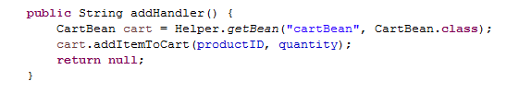
A Helper class (Helper.java) is provided. Add this class to your project, and call the getBean() method to get the "cartBean" bean as follows:
CartBean cart = Helper.getBean("cartBean", CartBean.class);
- removeHandler() method – Handles the "Remove" button click event, to remove an item from the user's shopping cart. To do this, invoke the removeItemFromCart() method on the "cartBean" bean.
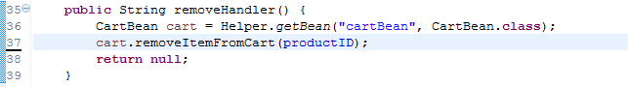

Step 3: Bind UI controls and events to the managed beans
In the web folder, open Shop.xhtml and remind yourself about the various JSF tags on the page. Then bind the following JSF tags to properties in the shopBean bean (i.e. the backing bean for this page):
- productsListBox - Set its value to the shopBean.productID property.
This will cause the value of the currently selected item to be copied into the productID property in the backing bean.
Also set onchange="this.form.submit();"
As soon as the user clicks an item in the list, the JavaScript onchange event will cause an immediate post-back to the server (so the productID property will be updated immediately to indicate the selected item).
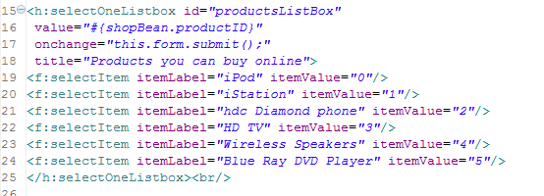
- productID text box - Set its value to the shopBean.productID property.
This will ensure the text box displays the currently selected product ID (i.e. the one the user selected in the list box).
- quantity text box - Set its value to the shopBean.quantity property.
This will cause the quantity value entered by the user to be copied into the quantity property in the backing bean.

Now bind the following JSF tags to event-handler methods in the ShopCart bean:
- add button - Set its action to the shopBean.addHandler method.
- remove button - Set its action to the shopBean.removeHandler method.
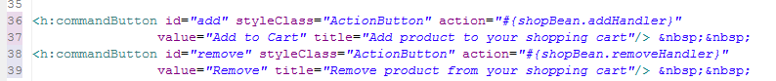

Step 4: Display the contents of the shopping cart
The last step is to display the contents of the shopping cart at the bottom of the page. This is how we want it to look when you've finished:
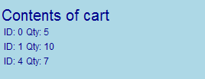
Hints:
- Add an <h:dataTable> to the xhtml page, and set its value to the cartBean.items property (this will bind the data table to an ArrayList<Item> collection).
- Define an <h:column> that displays the productID property for each item.
- Define another <h:column> that displays the quantity property for each item.
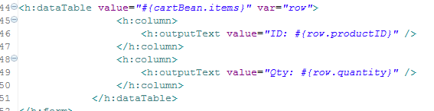

Run the web application and test it as follows:
- Select an item in the products list. Verify that its product ID appears in the Product ID text box. (Why does this happen…?)
- Enter a quantity, and then click the Add to Cart button.
- Verify that the data table displays one item, for the product ID and quantity you just specified.
- Repeat the previous steps a few times to add several items to the cart. Verify that the data table displays all the items.
- Click the Remove button to remove an item from the cart. Verify that the data table indicates the item has been removed.

